Beyond the Swipe: Predicting Dating App Match Outcomes

Group Project Report
Course: WIA1006 Machine Learning
Occurrence: 2
Group: Group 5 — Team TrueLove
Project Resources:
- Presentation Video: Google Drive Video
- Google Colab Notebook: Colab Notebook
- Streamlit Dashboard Demo: Streamlit Dashboard

Team Member | Matric Number | Technical Responsibility
Tan Jun Yong | 25005715 | Project coordination, pipeline architecture, model integration
Ng Hong Jon | 25005754 | Data preprocessing, feature encoding, exploratory data analysis
Loo Jiun Wei | 25006149 | Random Forest modelling, GridSearchCV tuning, results interpretation
Tan Kang Zheng | 25005697 | SVD/t-SNE visualization, metric evaluation, error analysis
Tan Sze Yung | 25005884 | Streamlit dashboard prototype, deployment testing, ethical discussion

Problem and Objective
This project investigates whether dating-app user data can predict match_outcome. The task was designed as a supervised 10-class classification problem, using the original target labels rather than simplifying them into fewer categories.
The ten target classes were: Blocked, Catfished, Chat Ignored, Date Happened, Ghosted, Instant Match, Mutual Match, No Action, One-sided Like, and Relationship Formed.
The dataset contains 50,000 synthetic user records, 24 predictor features, and one target variable. Features include demographic information, app behaviour, swipe patterns, interaction signals, interest tags, and relationship preferences.
The main objective was not only to build predictive models, but also to test whether the synthetic dataset contains meaningful learnable signal. Since the target classes are nearly balanced, the expected chance- level performance is approximately 10% accuracy.

Methodology and Model Explanation
The dataset was inspected before modelling. It contained no missing values and no duplicate rows, so no imputation was required.
The preprocessing pipeline was based on feature type:

Feature Type | Examples | Transformation
Numerical | age, app usage time, likes received, mutual matches | StandardScaler
Categorical | gender, location type, income bracket, relationship intent | OneHotEncoder
Multi-value text | interest_tags | CountVectorizer

The data was split using an 80/20 train-test split with a fixed random state for reproducibility. The target column was removed before preprocessing to avoid target leakage.
Six machine learning models were evaluated:
- Logistic Regression
- Decision Tree
- Random Forest
- K-Nearest Neighbours (KNN)
- Support Vector Machine (SVM)
- Gradient Boosting
After the initial comparison, GridSearchCV was used to tune Random Forest hyperparameters. Random Forest was selected for tuning because it is a strong non-linear ensemble model suitable for mixed structured data.

Results and Visualization

Model Performance Summary

Model | Accuracy | Weighted F1 | Interpretation
Dummy Baseline | 10.22% | 0.0190 | Majority-class benchmark
Logistic Regression | 9.94% | 0.0991 | Near chance level
Decision Tree | 9.43% | 0.0943 | Near chance level
Random Forest | 9.90% | 0.0986 | Near chance level
KNN | 9.55% | 0.0903 | Near chance level
SVM | 9.61% | 0.0959 | Near chance level
Gradient Boosting | 9.61% | 0.0950 | Near chance level
Tuned Random Forest | 10.15% | 0.1009 | Best tuned model, still near baseline
FLAML AutoML | 9.73% | 0.0741 | AutoML fallback; below tuned Random Forest

The Dummy Baseline achieved 10.22% accuracy, which is expected because the dataset has ten nearly balanced classes. The best tuned model, Random Forest with GridSearchCV, achieved only 10.15% accuracy. This is not a meaningful improvement over chance-level prediction.
The confusion matrix showed no strong diagonal pattern, meaning the model did not consistently predict the correct class. Class-level precision, recall, and F1-scores were also close to 0.10, confirming that no outcome class was predicted reliably.

SVD and t-SNE Visualization
Dimensionality reduction was used to inspect whether the transformed feature space contained visible class separation.
TruncatedSVD showed heavy overlap among the ten classes. t-SNE also showed mixed clusters with no clear boundary between match outcomes.
These visualizations support the metric results: the 24 features do not form separable patterns for the ten target classes.
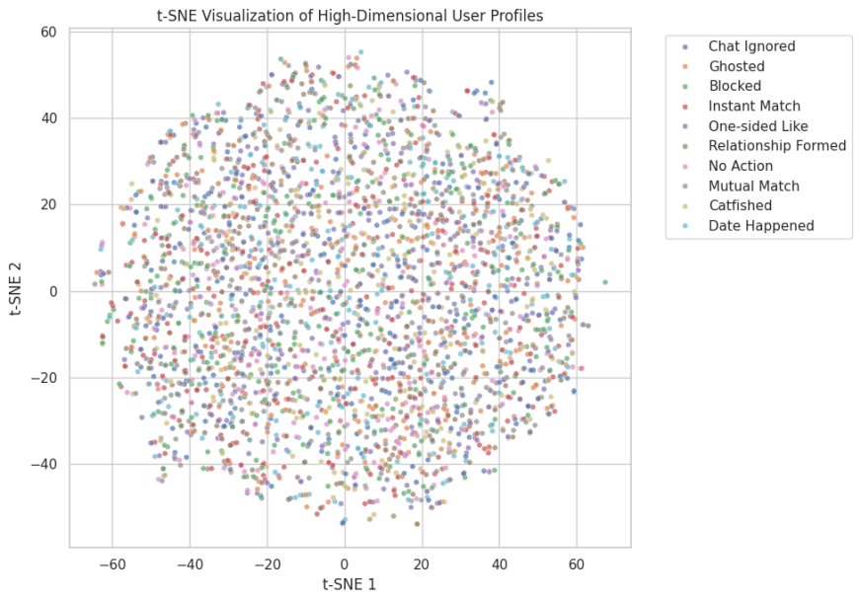
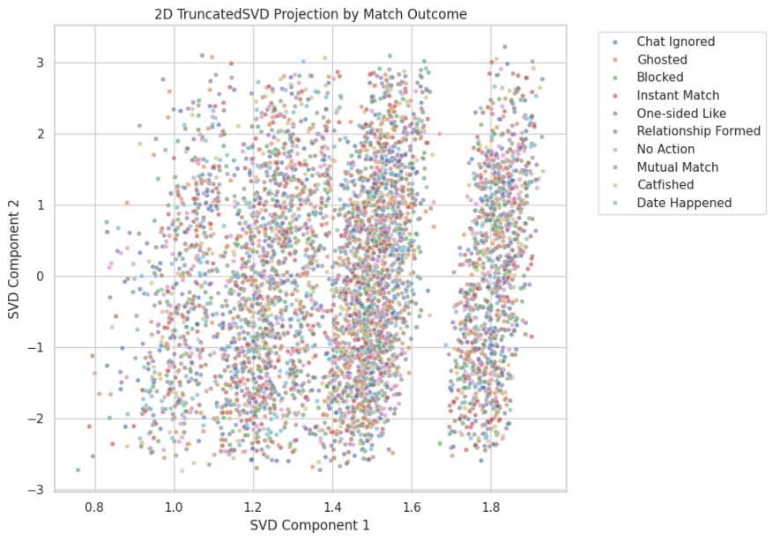

Comparison to Auto-Sklearn and AutoML Fallback
Auto-sklearn was treated as the requested AutoML benchmark. In the available runtime, the autosklearn package could not be imported, so the notebook recorded this limitation transparently and used FLAML AutoML as a practical fallback under the same train-test split and preprocessing design.
The FLAML fallback achieved 9.73% accuracy and a weighted F1-score of 0.0741, which was below the tuned Random Forest result. This supports the main conclusion that the dataset has weak feature-target signal rather than a problem that can be solved simply by switching to a more automated model search.
AutoML can optimise models and hyperparameters, but it cannot create predictive information that is absent from the data.
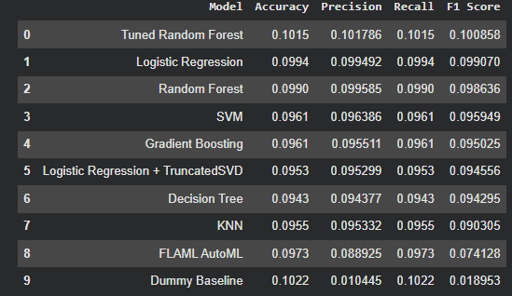

Insights and Interpretation
The key finding is that the synthetic dataset does not contain enough learnable structure to predict match_outcome.
Although the features appear realistic, such as swipe-right ratio, likes received, message count, mutual matches, and relationship intent, they do not meaningfully explain the target labels. This is shown by:

Evidence | Finding
Target setup | 10 nearly balanced classes
Chance benchmark | Approximately 10%
Dummy Baseline | 10.22% accuracy
Best tuned model | 10.15% accuracy
Model comparison | All six models near chance
SVD/t-SNE | No clear class separation
Confusion matrix | No strong diagonal pattern

The project therefore demonstrates the “Garbage In, Garbage Out” principle. Model complexity cannot overcome weak or random feature-target relationships. If the synthetic target labels were not generated from meaningful behavioural patterns, machine learning models cannot reliably predict them.
This is a valid scientific result. The low accuracy does not indicate poor implementation; it shows that the dataset itself is unsuitable for reliable prediction.

Streamlit Dashboard Prototype
A Streamlit dashboard prototype was developed to demonstrate deployment. Users can enter profile, behaviour, interaction, and preference details. The dashboard then displays model-assigned probabilities for the ten match outcomes.
However, because the model performs near chance level, the dashboard is clearly labelled as an educational prototype, not a real dating advice system. This is important because relationship outcomes involve complex human factors that are not captured by surface-level app data.

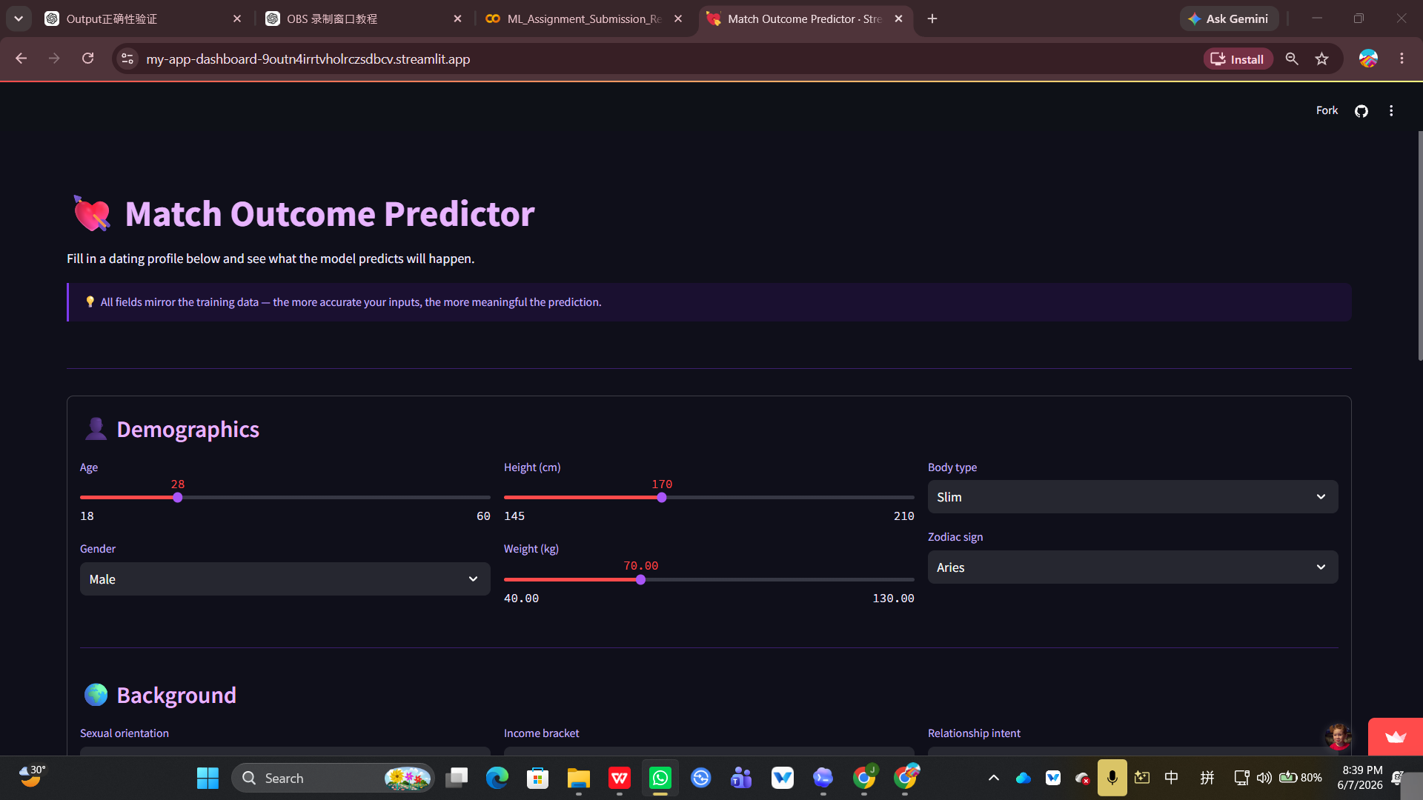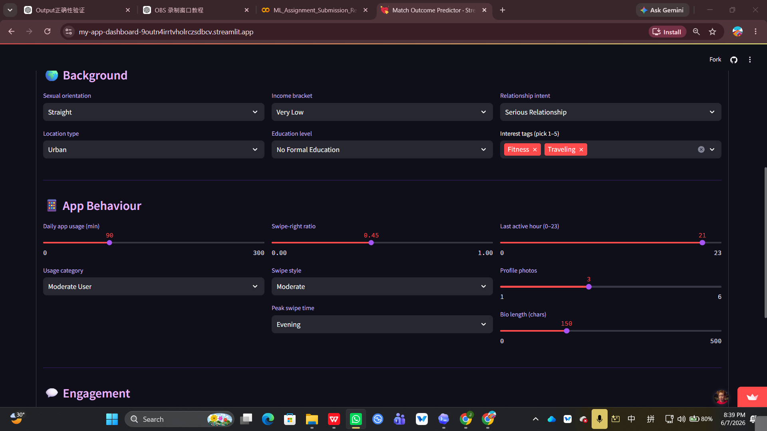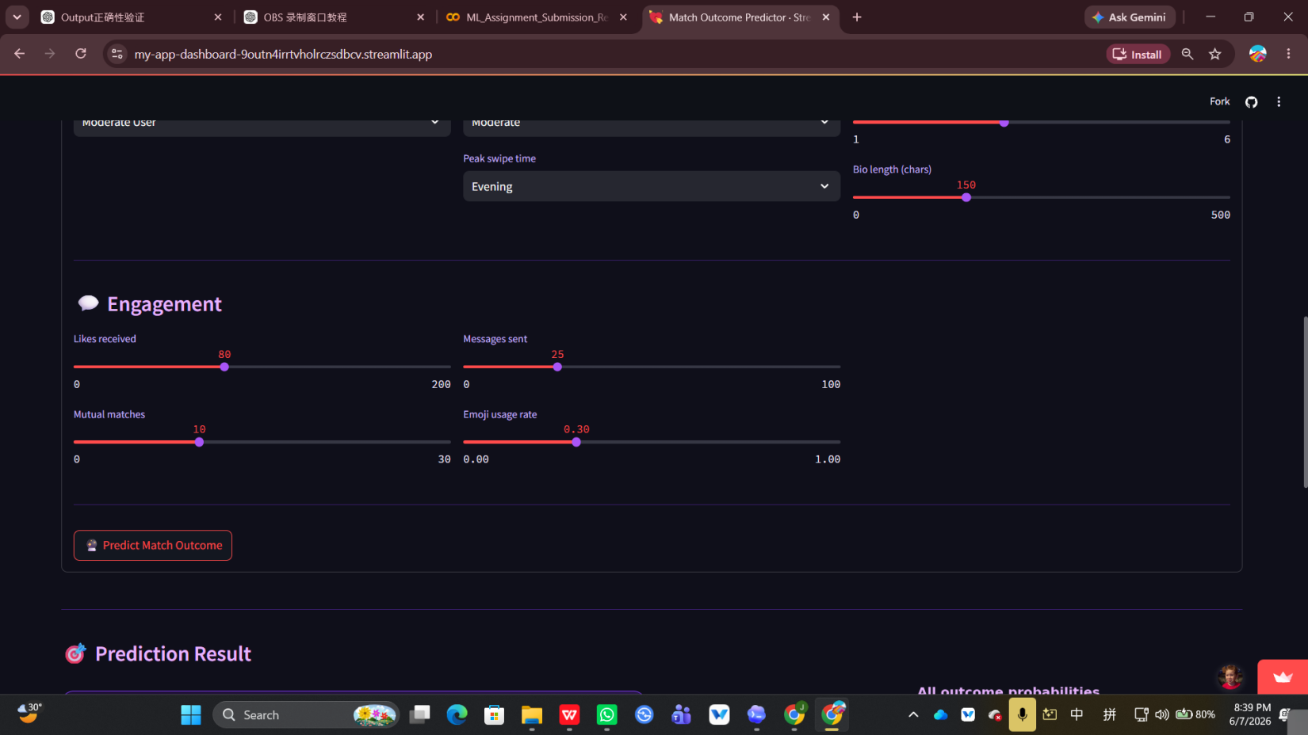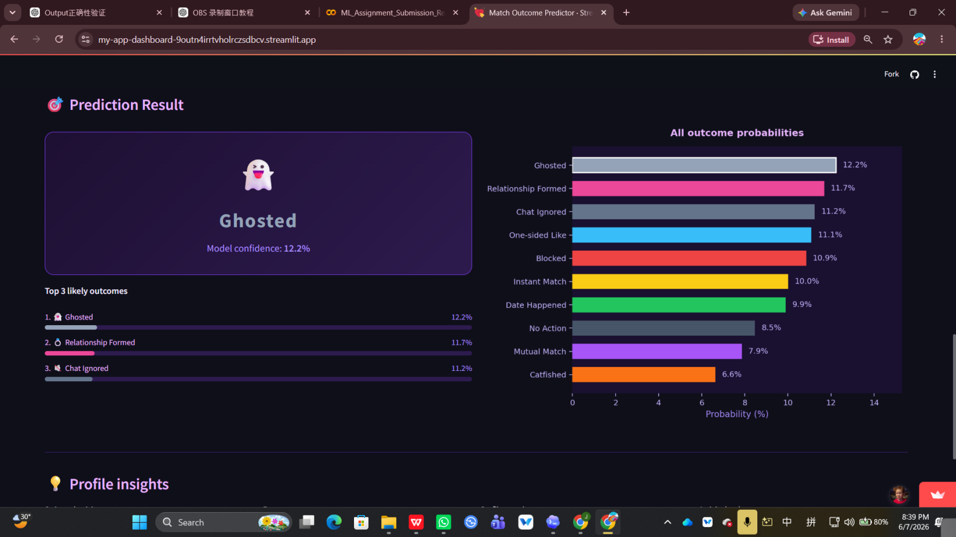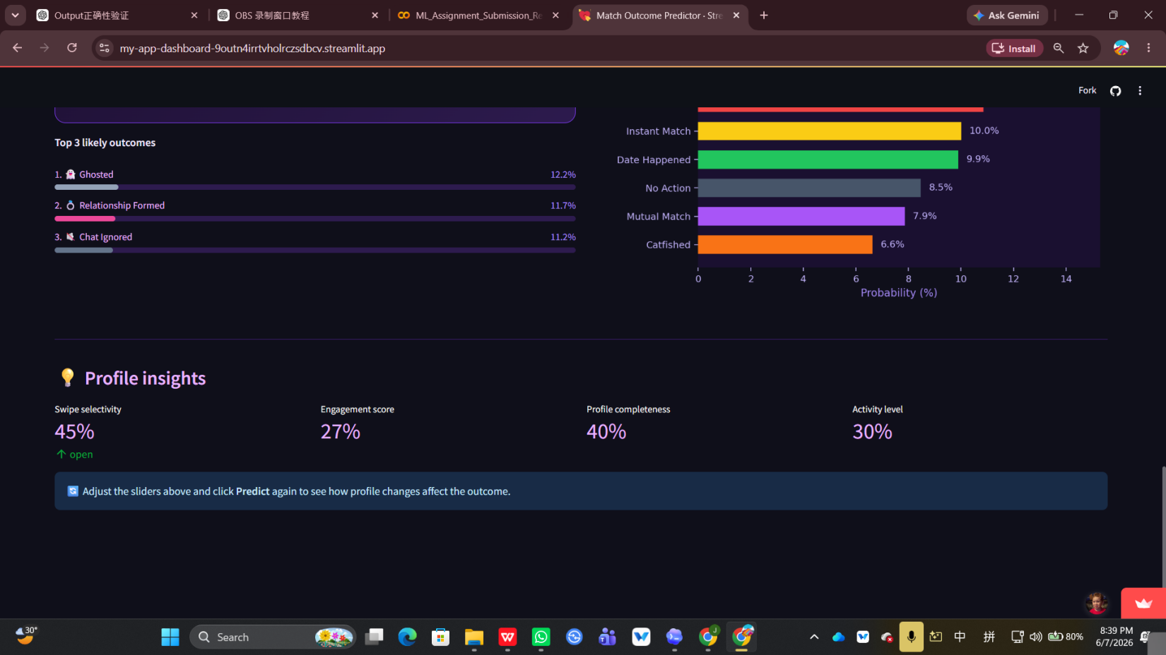

Responsible and Ethical Use
Because relationship outcomes involve sensitive social behaviour, the model was framed as an educational prototype rather than a decision-making system. The dashboard warning, low-confidence interpretation, and near-chance performance discussion prevent users from treating the output as personal dating advice.
The dataset is synthetic, so the project avoids making claims about real individuals or groups. The final interpretation focuses on model reliability, data limitations, and professional communication of uncertainty, which supports ethical reporting of machine learning results.

Conclusion
Group 5, Team TrueLove successfully developed a complete machine learning workflow for predicting dating-app match outcomes. The project included preprocessing, feature transformation, six-model comparison, GridSearchCV tuning, dimensionality reduction, evaluation, auto-sklearn/FLAML AutoML comparison, and Streamlit prototype deployment.
The project retained the original 10-class target, making the task more rigorous and realistic. The Dummy Baseline achieved 10.22% accuracy, while the best tuned model, Random Forest, achieved 10.15% accuracy. Since this result remains near chance level, the models did not learn meaningful predictive patterns.

The final conclusion is clear: the synthetic dataset lacks sufficient signal for predicting relationship outcomes. This supports the "Garbage In, Garbage Out" principle in machine learning. The Streamlit prototype is educational only, not dating advice.

